**Practical – 3**

1. Create a table “Employee” with following attributes :

| **Field Name** | **Data Type** | **Size** |
| --- | --- | --- |
| EmpCode | NUMBER | - |
| Name | VARCHAR2 | 6 |
| Salary | NUMBER | - |

**Solution:**

CREATE TABLE Employee (

EmpCode NUMBER,

Name VARCHAR2(6),

Salary NUMBER

);

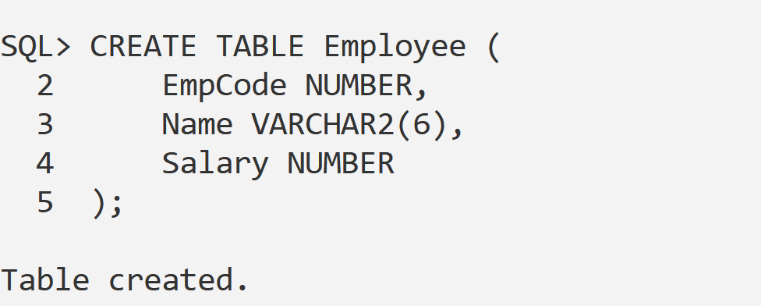

1. Display the structure of table

**Solution:**

DESC Employee;

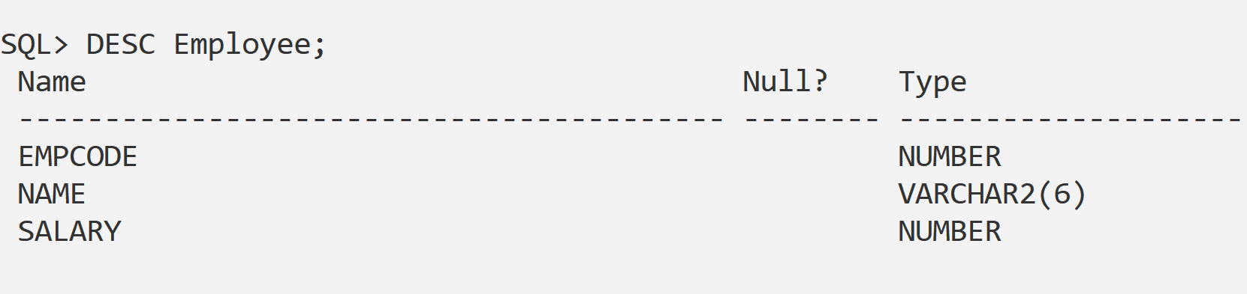

1. Increase the size of name column to 25.

**Solution:**

ALTER TABLE Employee

MODIFY Name VARCHAR2(25);

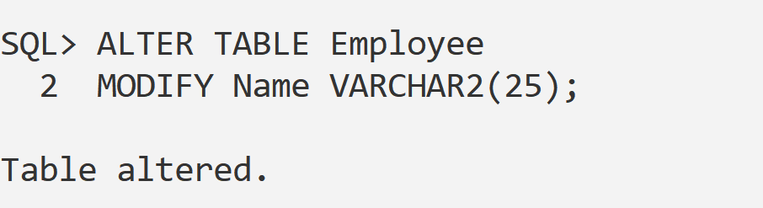

1. See the structure of table again.

**Solution:**

**DESC Employee;**

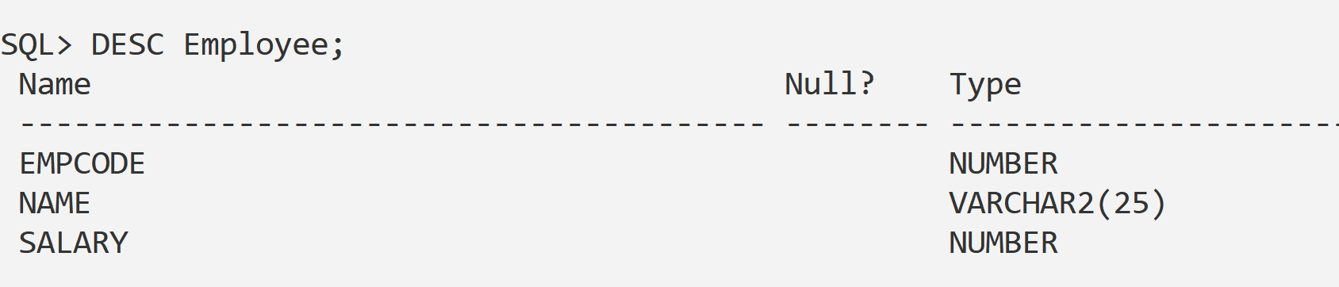

1. Drop the columns “name” and “empcode” from Emp table.

**Solution :**

ALTER TABLE Employee

DROP COLUMN Name;

ALTER TABLE Employee

DROP COLUMN EmpCode;

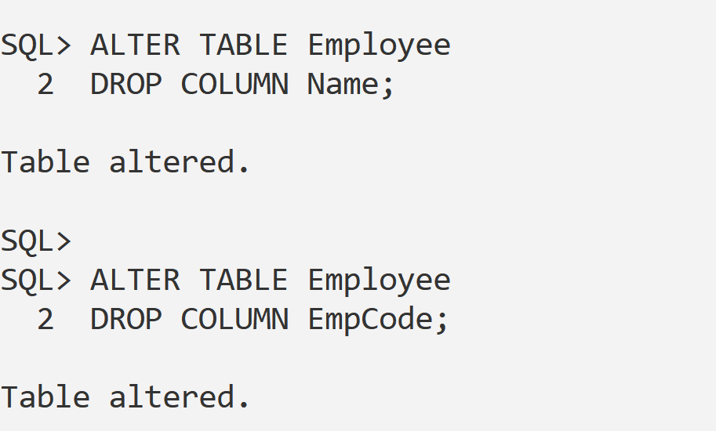

1. Change table name Emp to Emp1

Solution:

RENAME Employee TO Emp1;

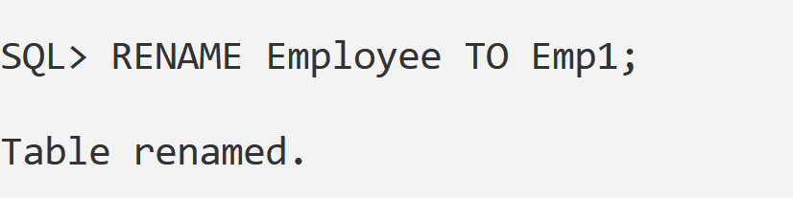

1. Drop the “Emp1” table.

Solution:

Drop Table Emp1;

